7th prgm

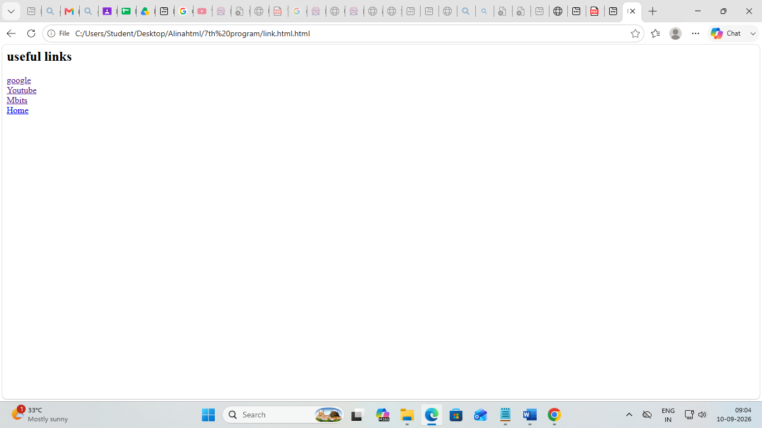

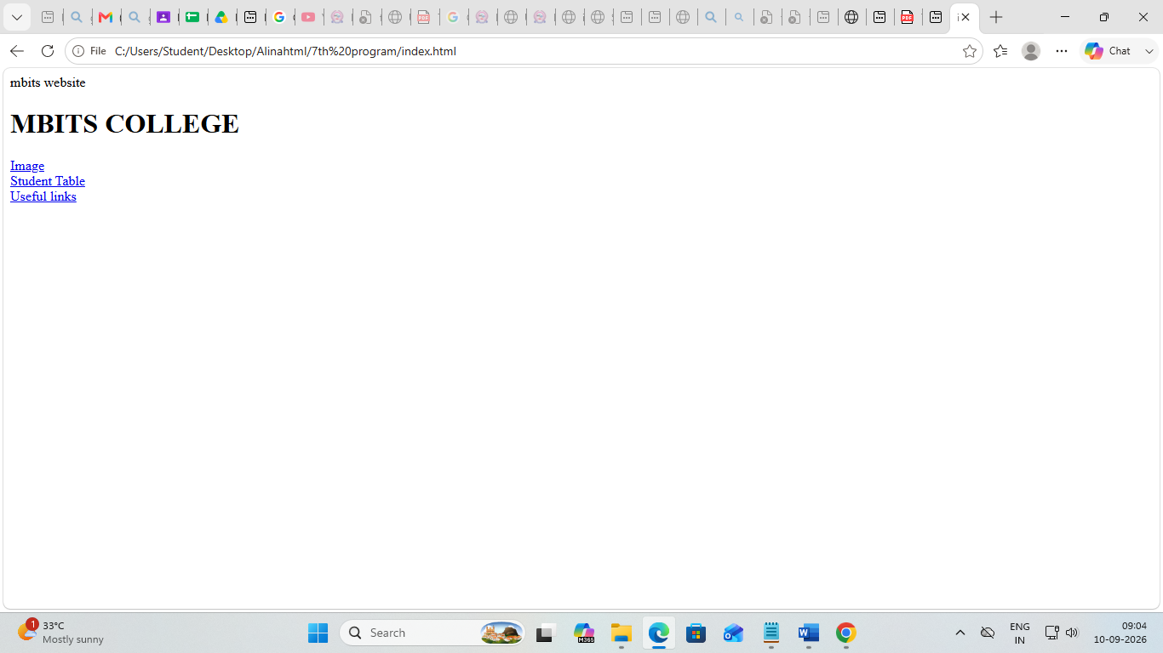

Code

Index.html

<html>
<head>
<tltle>mbits website</title>
</head>
<body>
<h1>MBITS COLLEGE</h1>

<a href="image.html">Image</a><br>
<a href="table.html">Student Table</a><br>
<a href="link.html.html">Useful links</a><br>
</body>
<html>

Image.html

<html>
<head>
<title>Images</title>
</head>
<body>
<h2>College Images</h2>
<center><img src="C:\Users\Student\Desktop\Alinahtml\mbitsimg.jpg" width=500 height=250 ></center>

<a href ="index.html">Home</a>
</body>

</html>

Table.html
<html>
<head>
<title>Student marksheet</title>
</head>
<body>
<h2 align="center">Student Marksheet</h2>
<table border="1" align="center">
<tr>
<th>Register Number</th>
<th>Student name</th>
<th>10th marks</th>
<th>Plus two marks</th>
<th>UG marks</th>
<th>percentage</th>
</tr>
<tr>
<td>1001</td>
<td>Alina Sajan</td>
<td>600</td>
<td>1100</td>
<td>3250</td>
<td>78.99</td>
</tr>
<tr>
<td>1002</td>
<td>karthika</td>
<td>600</td>
<td>1100</td>
<td>3250</td>
<td>56.99</td>
</tr>
<tr>
<td>1003</td>
<td>malavika</td>
<td>600</td>
<td>1100</td>
<td>3250</td>
<td>60</td>
</tr>
<tr>
<td>1004</td>
<td>Sajan</td>
<td>600</td>
<td>1100</td>
<td>3250</td>
<td>78.99</td>
</tr>
<tr>
<td>1005</td>
<td>Alaster</td>
<td>600</td>
<td>1100</td>
<td>3250</td>
<td>78.99</td>
</tr>
</body>
</html>

Link.html
<html>
<head>
<title>Usefull links</title>
</head>
<body>
<h2>useful links</h2>
<a href ="https://www.google.com">google</a><br>
<a href ="https://www.youtube.com">Youtube</a><br>
<a href ="https://mbits.ac.in">Mbits</a><br>
<a href ="index.html">Home</a>
</body>
</head>
</html>

